# MAEG 5720 Computer Vision in Practice

# Project 2

XIA, Lei 1155169110

Dr. Terry Chang

December 10, 2021

The following is image 1.

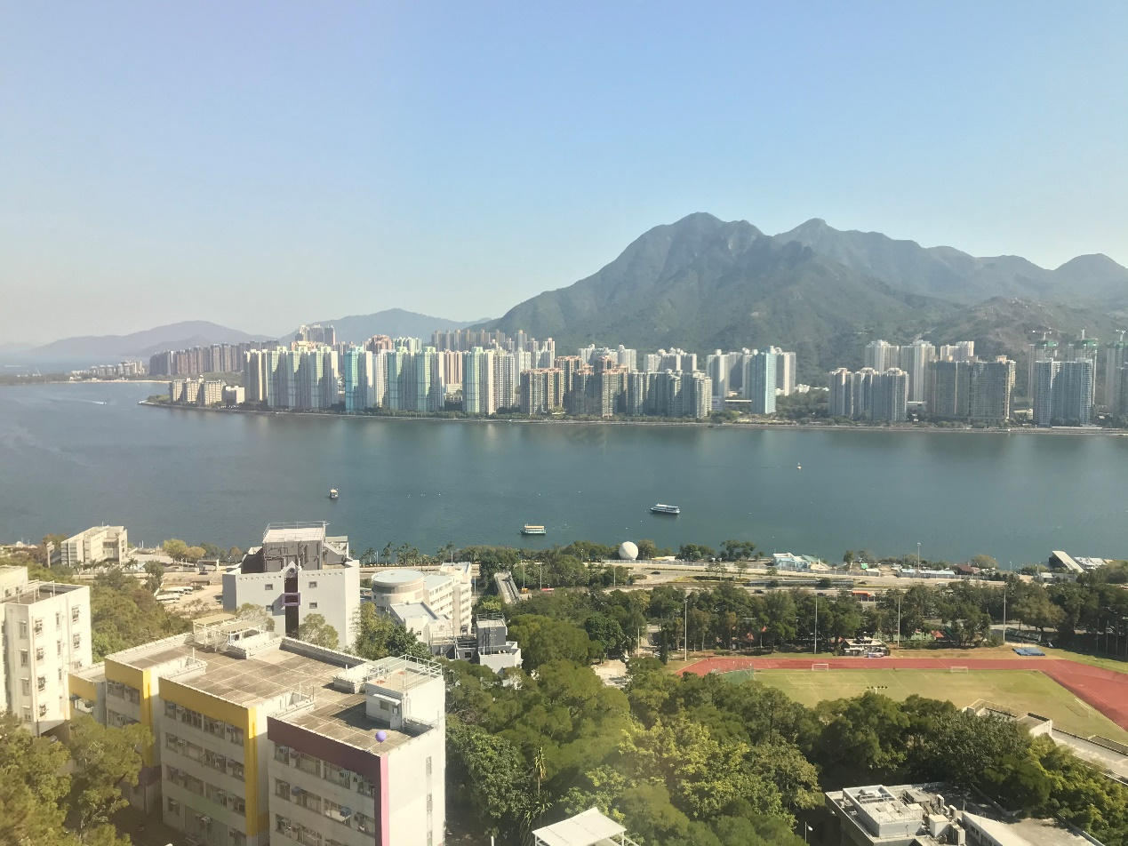

The following is image 2.



The following is stitched image after cropping.

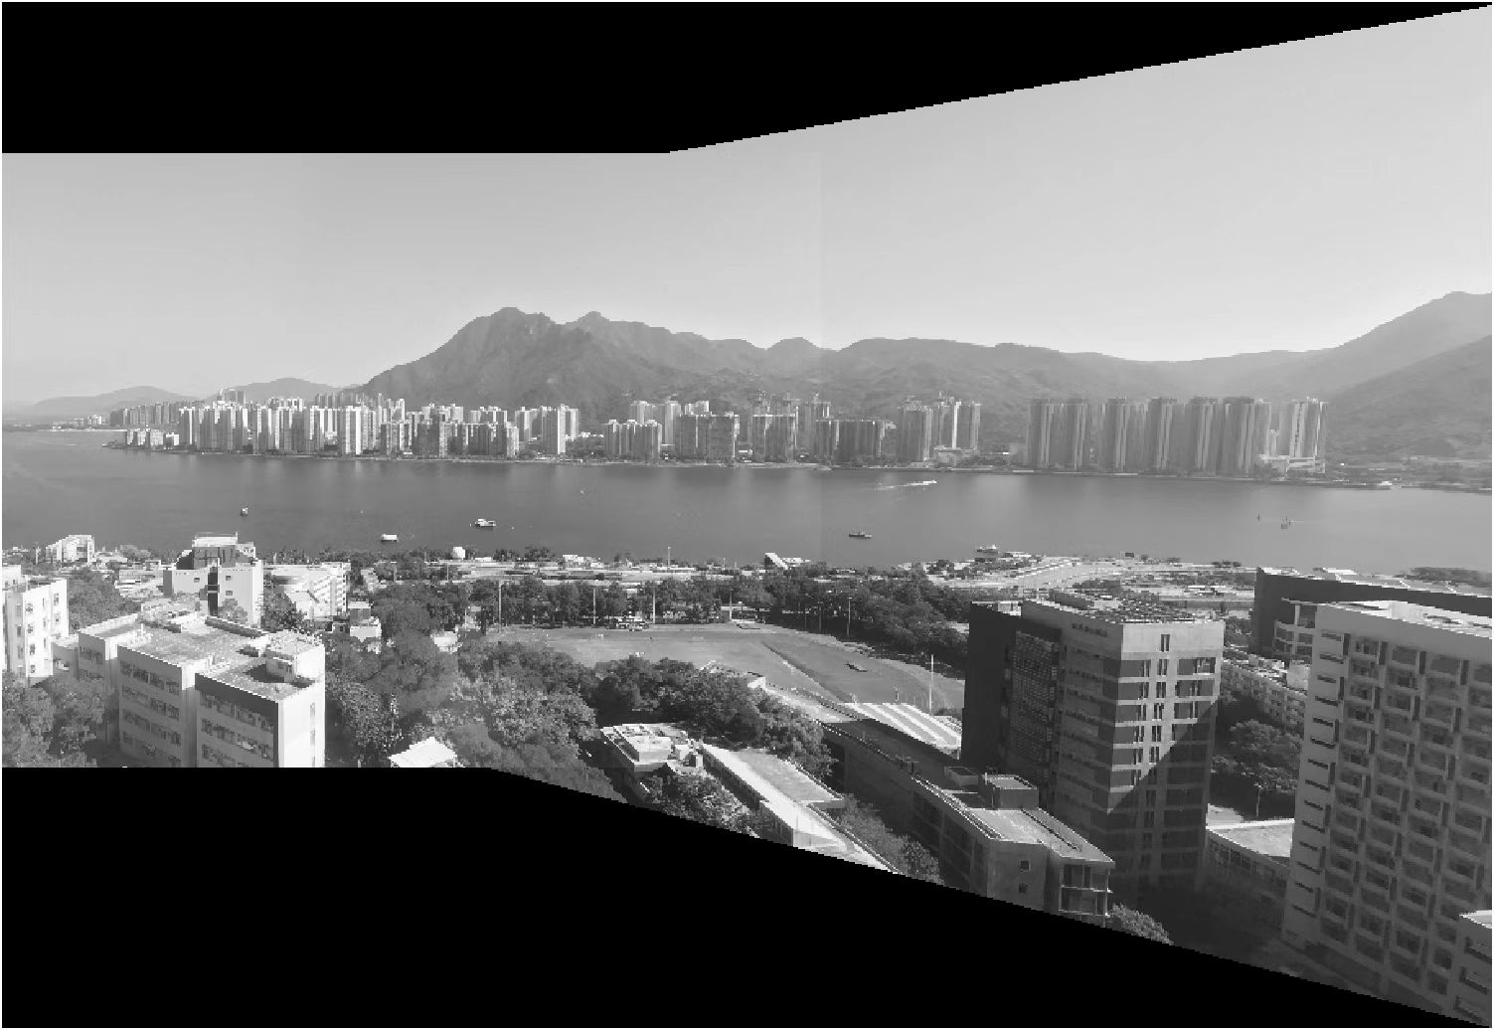

The following is the stitched image of 3 pictures.

